**Create Git remote repository using Git account:** 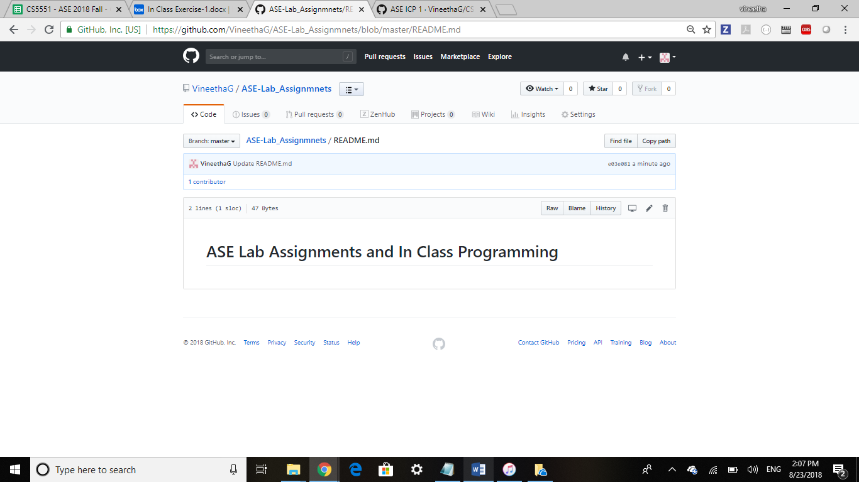

### Cloning Repository to local and creating folders:

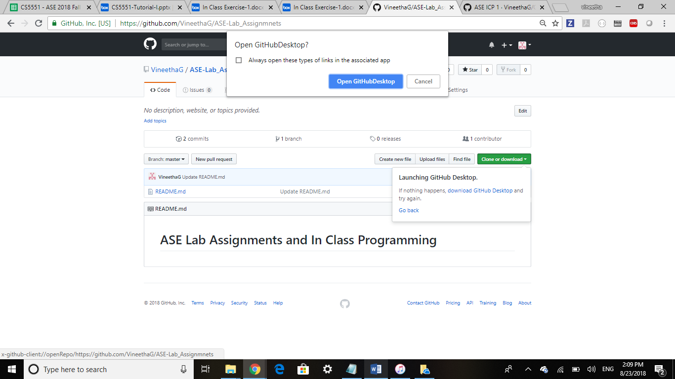

Cloned to local

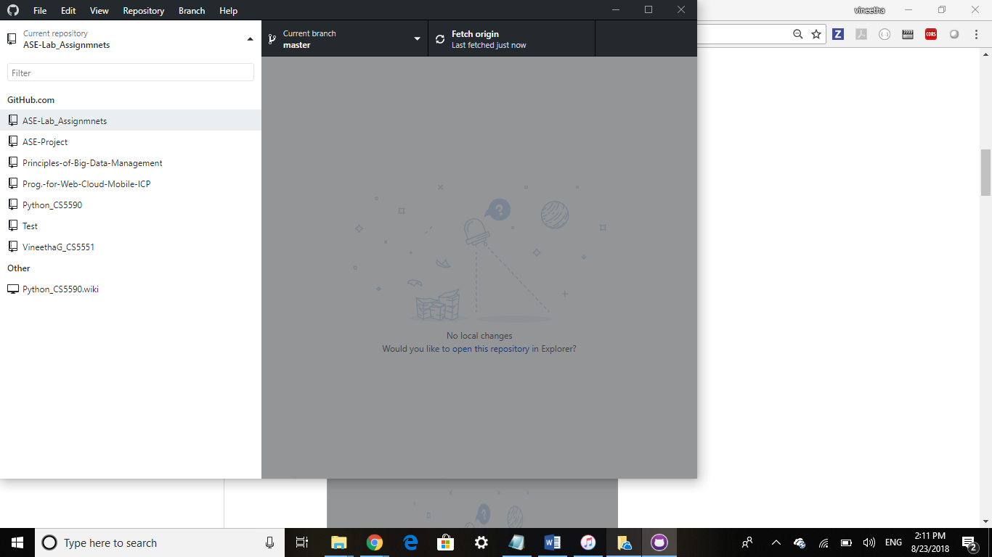

Created a sample file in local repository.